**Assignment II**

**Waiting Lines**

**Problem1:** McBurger's fast-food restaurant has a drive-through window with a single server who takes orders from an intercom and also is the cashier. The window operator is assisted by other employees who prepare the orders. Customers arrive at the ordering station prior to the drive-through window every 4.5 minutes (Poisson distributed), and the service time is 2.8 minutes (exponentially distributed). Determine the average length of the waiting line and the waiting time. Discuss the quality of the service.

$k=1$ $λ=\frac{60}{4.5}=13.3 customers per hour$

$$μ=\frac{60}{2.8}=21.4 customers per hour$$

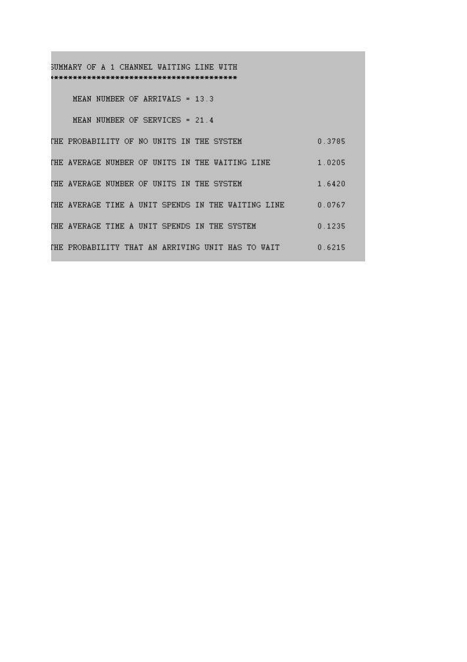

*The average length of the waiting line is the average number of customers in the waiting line which is 1.02 customer. The average waiting time is 0.0767 * 60 = 4.602 minutes.*

**Problem 2:** The First American Bank of Rapid City has one outside drive-up teller. It takes the teller an average of 4 minutes to serve a bank customer. Customers arrive at the drive-up window at a rate of 12 per hour. The bank operations officer is currently analyzing the possibility of adding a second drive-up window, at an annual cost of $20,000. It is assumed that arriving cars would be equally divided between both windows. The operations officer estimates that each minute's reduction in customer waiting time would increase the bank's revenue by $2,000 annually. Should the second drive-up window be installed?

$k=1$ $λ=12 customers per hour$

$$μ=\frac{60}{4}=15 customers per hour$$

*Cost per channel = $20,000*

*Cost per waiting unit = $2,000*

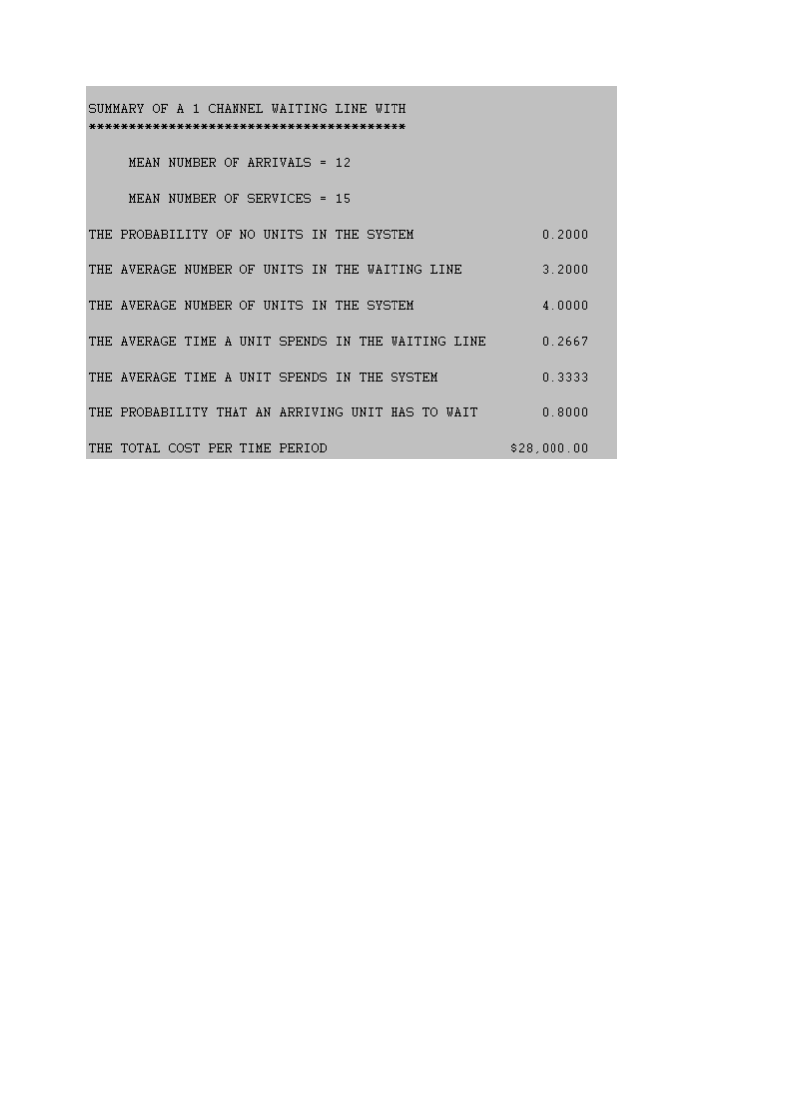

$k=2$ $λ=12 customers per hour$

$$μ=\frac{60}{4}=15 customers per hour$$

*Cost per channel = $20,000*

*Cost per waiting unit = $2,000*

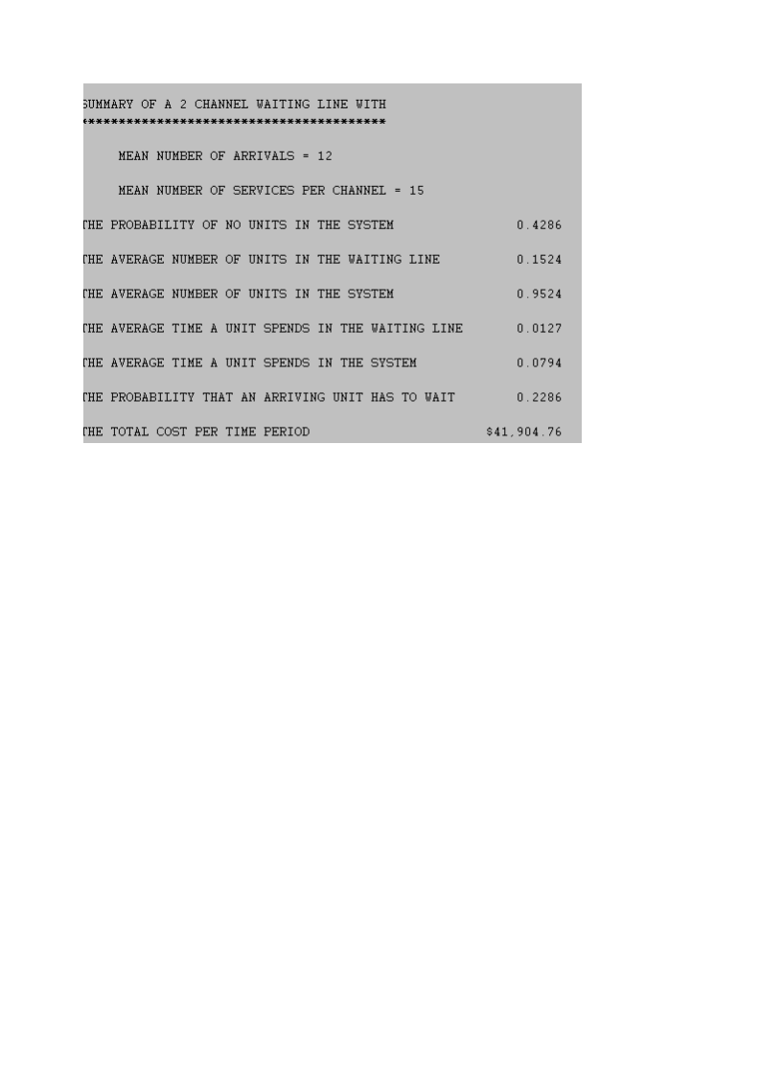

*Based on the operating system characteristics, adding a second officer is better since it enhances the operating characteristics such as the average waiting customers of the customers and the number of customers waiting. On the other hand, this alternative is more costly than working with one teller.*